PERSONAL FINANCE MANAGEMENT SYSTEM
A MINI-PROJECT REPORT
Submitted by

DHANUSRI R S 241801051
DHANALAKSHMI M 241801050
KEERTHANA T 241801123

in partial fulfillment of the award of the degree
of
BACHELOR OF TECHNOLOGY
IN
ARTIFICIAL INTELLIGENCE AND DATA SCIENCE

RAJALAKSHMI ENGINEERING COLLEGE, CHENNAI
An Autonomous Institute
CHENNAI
NOVEMBER 2025

BONAFIDE CERTIFICATE
Certified that this project “PERSONAL FINANCE MANAGEMENT SYSTEM” is the bonafide work of “DHANALAKSHMI M, DHANUSRI R S, KEERTHANA T” who carried out the project work under my supervision.

SIGNATURE
R. SAVITRI
Rajalakshmi Engineering College
Chennai

This mini project report is submitted for the viva voce examination to be held on __________

INTERNAL EXAMINER EXTERNAL EXAMINER

ABSTRACT

The Personal Finance Management System (PFMS) is a web-based application designed to assist users in managing their financial activities effectively and efficiently. The system provides an integrated platform for recording income, categorizing expenses, setting and tracking budgets, and analyzing overall financial performance through interactive visual reports. By leveraging a robust database-driven architecture, PFMS ensures accurate data storage, retrieval, and analysis, enabling users to gain valuable insights into their spending patterns. The system aims to promote financial awareness, encourage responsible money management, and enhance financial literacy among users. Through its user-friendly interface and data-driven analytics, PFMS empowers individuals to make informed financial decisions and achieve better control over their personal finances

ACKNOWLEDGEMENT

We express our sincere thanks to our beloved and honorable chairman MR. S. MEGANATHAN and the chairperson DR. M.THANGAM MEGANATHAN for their timely support and encouragement.
We are greatly indebted to our respected and honorable principal
Dr. S.N. MURUGESAN for his able support and guidance.
No words of gratitude will suffice for the unquestioning support extended to us by our Head Of The Department Dr.GNANASEGAR J M for being ever supporting force during our project work
We also extend our sincere and hearty thanks to our internal guide Dr.SAVITRI R, for her valuable guidance and motivation during the completion of this project.
Our sincere thanks to our family members, friends and other staff members of Artificial Intelligence and Data Science
1. DHANALAKSHMI M
2.DHANUSRI R S
3.KEERTHANA T
TABLE OF CONTENTS

CHAPTER NO. TITLE PAGE NO
ABSTRACT iv

1 INTRODUCTION 7
1.1 INTRODUCTION 7
1.2 SCOPE OF THE WORK 7
1.3 PROBLEM STATEMENT 7
1.4 AIM AND OBJECTIVES OF THE PROJECT 7
2 SYSTEM SPECIFICATIONS 8
2.1 HARDWARE SPECIFICATIONS 8
2.2 SOFTWARE SPECIFICATIONS 8
3 MODULE DESCRIPTION 9
4 CODING 10
5 SCREENSHOTS 13
6 CONCLUSION AND FUTURE ENHANCEMENT 16
REFERENCES 17

LIST of figures
FIGURE NO. | TITLE | PAGE NO.
5.1 | Login page | 13
5.2 | Home page | 13
5.3 | Adding an Expense | 14
5.4 | Adding Income | 14
5.5 | Deletion of an Entry | 15
5.6 | Database creation | 15

CHAPTER 1
INTRODUCTION
  - INTRODUCTION

The project helps users manage their personal finances efficiently.
It provides necessary information about income, expenses, and budgets according to user convenience. Users can record their earnings, categorize expenses, and analyze their financial performance to make better financial decision.

  - SCOPE OF THE WORK
The Personal Finance Management System enables users to track and manage their financial activities easily. It helps maintain records of income, expenses, and budgets and provides visual reports for better understanding. The system promotes financial awareness and responsible spending among users.e
  - .PROBLEM STATEMENT
Many people find it difficult to monitor their daily financial activities due to a lack of proper tracking tools. Managing expenses manually often leads to errors and confusion. Hence, there is a need for a system that allows users to store and analyze their financial data in a structured and user-friendly way.
1.4 AIM AND OBJECTIVES OF THE PROJECT
The main objective of this project is to help users maintain a record of income and expenses efficiently. This system provides categorized storage of transactions and generates visual reports for better decision-making. It aims to promote organized financial management and awareness among individuals.
CHAPTER 2
SYSTEM SPECIFICATIONS
2.1 HARDWARE SPECIFICATIONS
Processor | : | Intel i5
Memory Size | : | 8GB (Minimum)
HDD | : | 1 TB (Minimum)

2.2 SOFTWARE SPECIFICATIONS
Operating System | : | WINDOWS 11
Front – End | : | HTML,CSS,Tsx
Back - End | : | MySql
Language | : | Sql,typescript

CHAPTER 3
MODULE DESCRIPTION
This application consists of two modules. When the program runs, it will ask for a confirmation to the login window. The person who interacts can login as an Administrator or as a User. The description of the modules are as follows:
- Admin login
When the person who interacts tries to login as Admin then he needs to login with his username and password. The administrator only has the power to change and manipulate the data in the database.
2. User login
When the person tries to login as a user then he/she will be prompted to enter
the number of symptoms and the final result will be printed in the form of
table.

CHAPTER 4
SAMPLE CODING
Sample 1
Sample 1 depicts the display code, that helps create the structure of tables in the backend database.

db.serialize(() => {
db.run(`CREATE TABLE IF NOT EXISTS users (
id INTEGER PRIMARY KEY AUTOINCREMENT,
username TEXT UNIQUE NOT NULL,
password TEXT NOT NULL
)`);

db.run(`CREATE TABLE IF NOT EXISTS transactions (
id INTEGER PRIMARY KEY AUTOINCREMENT,
date TEXT NOT NULL,
type TEXT NOT NULL,
category TEXT,
description TEXT,
amount REAL NOT NULL,
created_at DATETIME DEFAULT CURRENT_TIMESTAMP
)`);

db.run(`CREATE TABLE IF NOT EXISTS budgets (
id INTEGER PRIMARY KEY AUTOINCREMENT,
month INTEGER NOT NULL,
year INTEGER NOT NULL,
amount REAL NOT NULL,
UNIQUE(month, year)
)`);

// Insert demo admin user if missing (password 'admin') - only for demo
db.get(`SELECT id FROM users WHERE username = ?`, ['admin'], (err, row) => {
if (err) console.error(err);
if (!row) {
db.run(`INSERT INTO users (username, password) VALUES (?, ?)`, ['admin', 'admin']);
console.log('Inserted demo user admin/admin');
}
});
});

Sample 2
Sample 2 depicts the login part of the code, where the user authentication is checked
/* ---------- AUTH & BOOT ---------- */
async function login(){
const u = document.getElementById('username').value.trim();
const p = document.getElementById('password').value.trim();
if(!u || !p){ document.getElementById('login-msg').innerText='Provide username & password'; return; }
try{
const resp = await fetch('/api/login', {
method: 'POST',
headers: {'Content-Type':'application/json'},
body: JSON.stringify({ username: u, password: p })
});
const j = await resp.json();
if(resp.ok && j.ok){
localStorage.setItem('pfms_auth','1');
location.href='dashboard.html';
} else {
document.getElementById('login-msg').innerText = j.error || 'Invalid credentials';
}
} catch(e){
document.getElementById('login-msg').innerText = 'Network error';
console.error(e);
}
}

function logout(){
localStorage.removeItem('pfms_auth');
location.href='index.html';
}

async function loadDashboard(){
if(!localStorage.getItem('pfms_auth')) { location.href='index.html'; return; }
// if first load and no data in DB, the server DB might be empty; we will not auto-seed here.
renderAll();
}

CHAPTER 5
OUTPUT SCREEN SHOTS
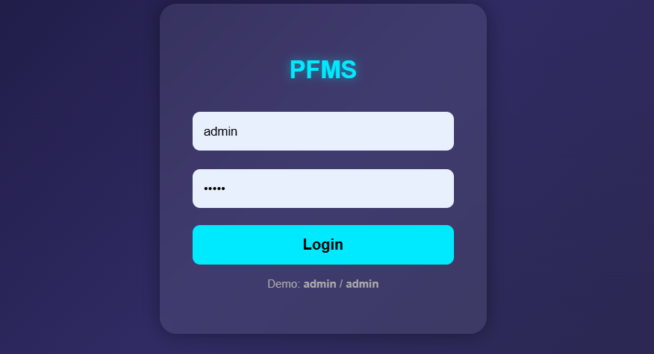
Fig 5.1 Login page
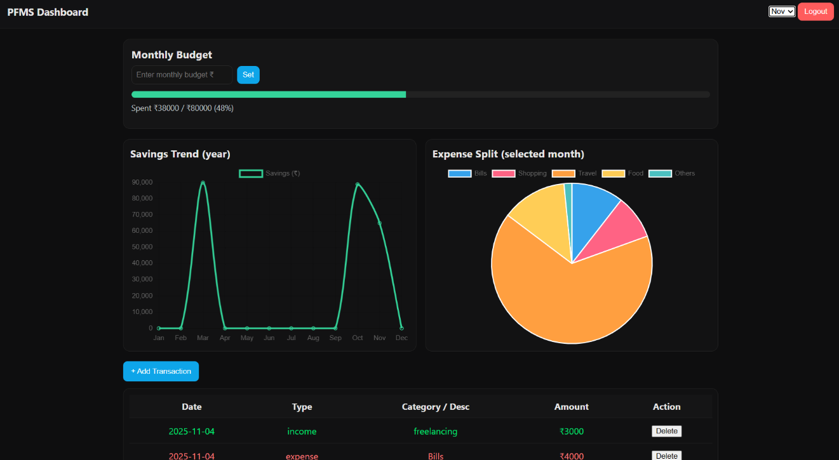
Fig 5.2 Home page

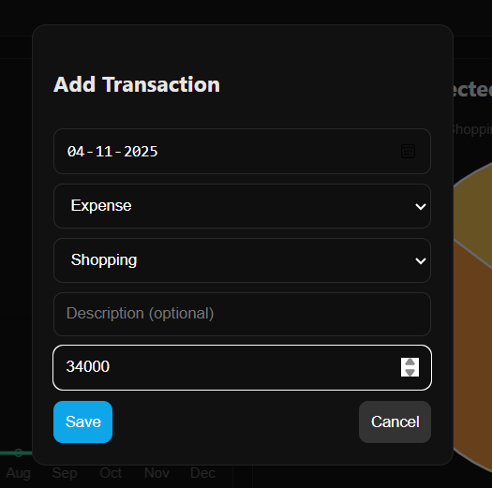
Fig 5.3 Adding an Expense
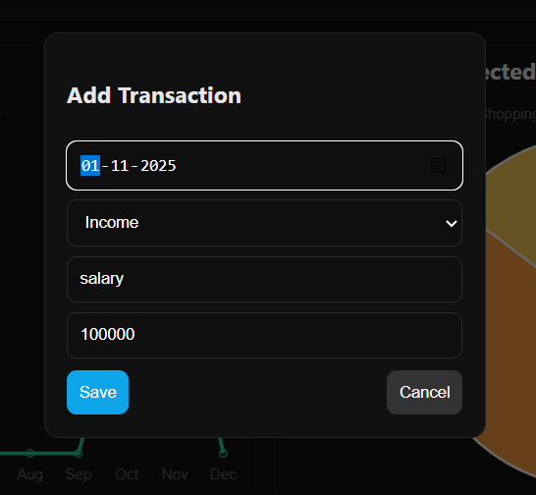

Fig 5.4 Adding Income
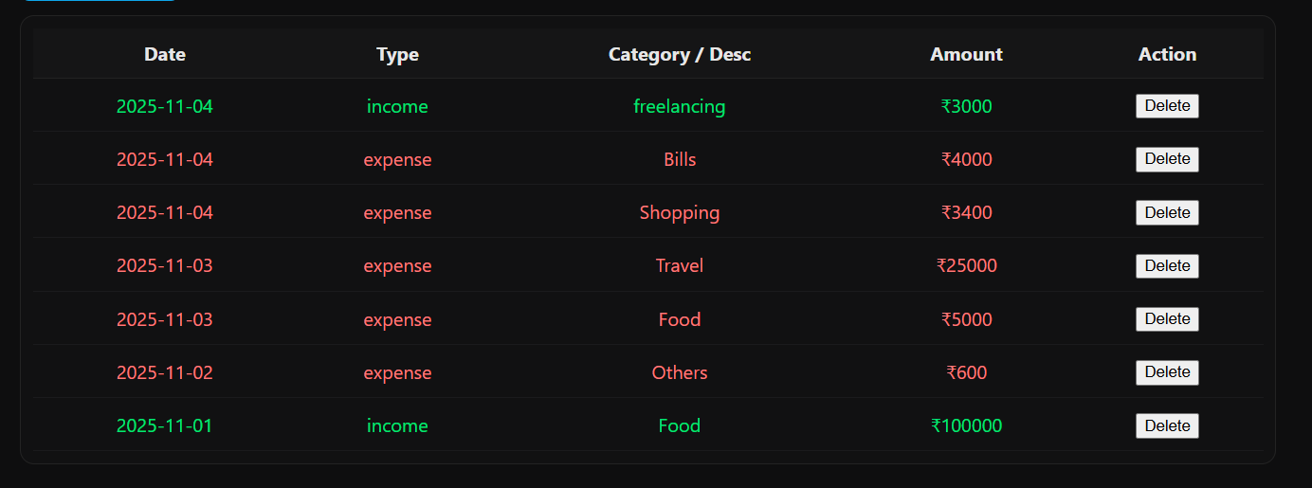
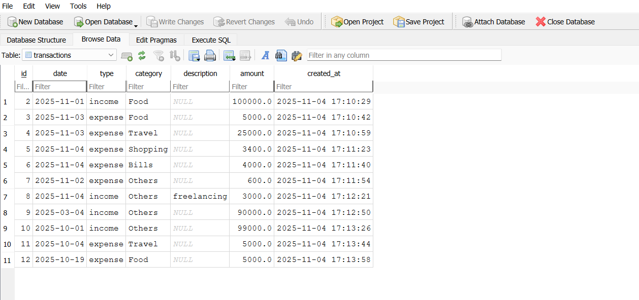
Fig 5.5 Deletion of an Entry

Fig 5.6 Database creation

CHAPTER 6
CONCLUSION AND FUTURE ENHANCEMENT
The Personal Finance Management System successfully provides users with an efficient and user-friendly platform to track income, expenses, and budgets. By offering categorized data storage and visual analytics, it simplifies financial management and encourages better financial decisions. In the future, the system can be enhanced by integrating advanced features such as:Automatic transaction import from bank APIs, AI-based spending prediction and financial advice, Mobile app synchronization for cross-device accessibility, Cloud storage integration for data backup and recovery.
This project thus lays a strong foundation for a scalable and intelligent personal finance management solution.

REFERENCES
- https://www.w3schools.com/sql/
- https://www.tutorialspoint.com/sqlite/index.htm
- https://www.wikipedia.org/
- https://www.learnpython.org/
- https://www.codecademy.com/learn/learn-python

